Project 3(b)

**Similar Image Retrieval using Canberra Distance**

Show the 10 most similar images of **a** **given object** for **Coil-80** dataset using *Canberrea* distance and following *texure features*: Maximum proability, Correlation, Contrast, Uniformity (Energy), Homogeneity, and Entropy, of **gray-level co-occurance matirx of image**.

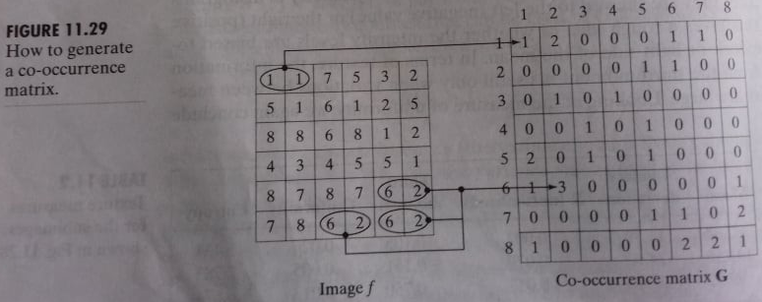

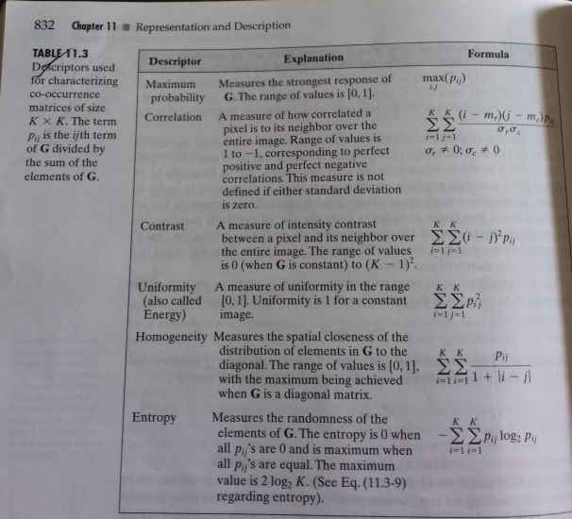

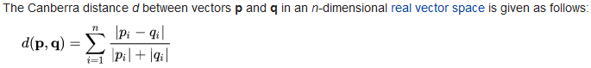

Use **GUI.** A sample GUI is shown below:

……………………………………………………

……………………………………………………..

**Query Image**

Show here the query image

**Similar Images**

Similar image1

Similar image6

Similar image5

Similar image10

Load Feature Data

(Browse Training feature Data file)

Extract Feature and store in database

Load Training images

(Browse Training image folder)

Display

(Extract query image feature and show the similar images)

Load Query image

(Browse Test image)